STEP 1: Sign in to AWS Management Console

1. Open the AWS Console.

2. Sign in with your IAM Username and Password.

3. Set the default AWS Region to Asia Pacific (Mumbai) ap-south-1.

STEP 2: Launch Two EC2 Instances

1. Go to Services > EC2.

2. Click Launch Instances.

3. Configure the instances:

- Number of instances: 2

- Name tag: MyEC2

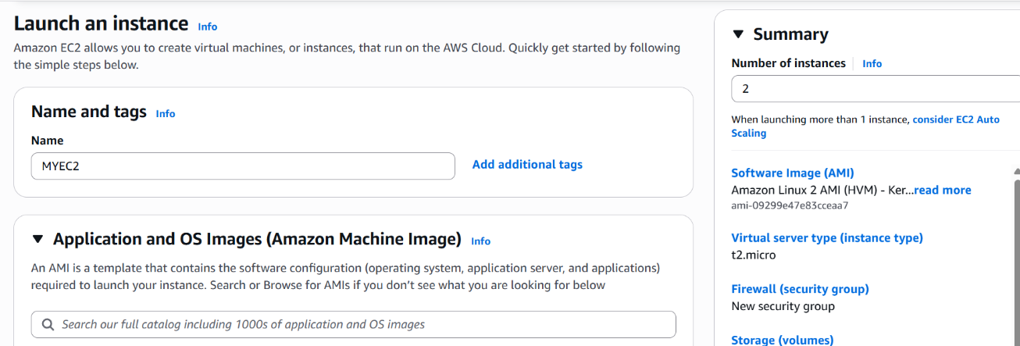

- AMI: Amazon Linux 2 AMI (64-bit x86)

* Instance Type: **t2.micro**

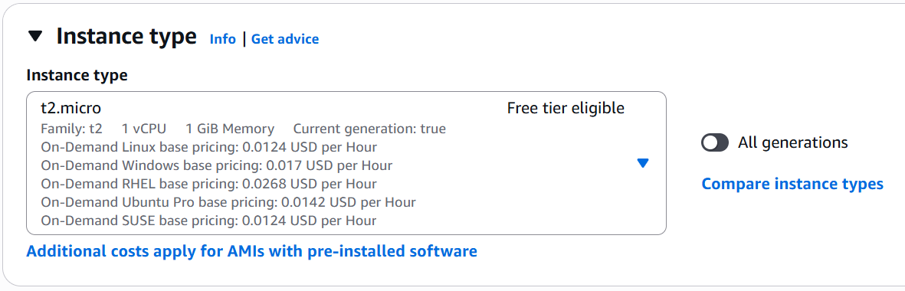

* **Key Pair**: Create a new key pair named MyEC2Key (Type: RSA, Format: .ppk). Download and save it.

**\*Network Settings:**

* Click on “Edit”
* **Enable** Auto-assign Public IP.

**Create a new security group named EFS Security Group and add a description**

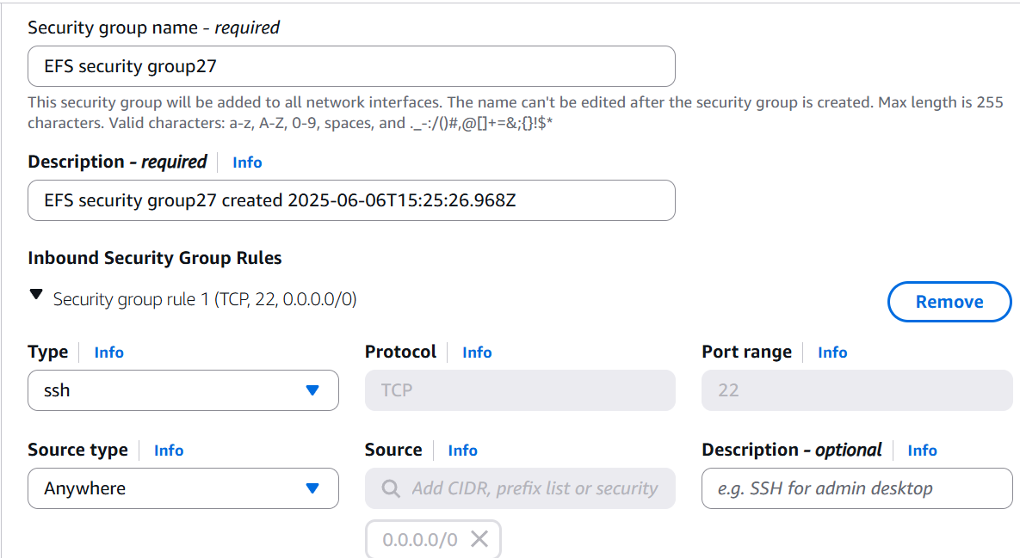

*Add rules:

* **SSH**: Type: SSH | Source: Anywhere
* **NFS**: Type: NFS | Source: Anywhere

1. Launch the instances.
2. Go to "View All Instances" and rename them to **MyEC2-1 and MyEC2-2**.

Note their IPv4 Public IP addresses.)

STEP 3: Create an Elastic File System (EFS)

1. Go to Services > EFS.
2. Click **Create file system.**

1. Customize the file system:

* Name: EFS-Demo
* VPC: Default VPC (for ap-south-1)
* Keep other settings as they are.

1. Click Next.
2. **Network access**:

* Ensure the Default VPC is selected.

* For each mount target in each Availability Zone, remove the default security group and select your EFS Security Group.

* Click Next (to skip file system policy), then Next again.

1. Review and click Create. Wait for the EFS to become "Available".

STEP 4: Mount EFS on MyEC2-1

Connect to MyEC2-1 instance

1. Switch to root: sudo -s

1. Update instance: yum -y update

1. Install EFS utilities: yum install -y amazon-efs-utils

1. Create mount directory: mkdir efs

1. Go to AWS Console > EFS > EFS-Demo > Attach.

1. Copy the "using the NFS client" command and paste it into your terminal:

1. Verify mount: df -h

STEP 5: Mount EFS on MyEC2-2

Connect to MyEC2-2 instance

1. Repeat all steps from STEP 4 for MyEC2-2.

STEP 6: Test the Shared File System (EFS)

1. Open two terminals and SSH into MyEC2-1 and MyEC2-2 respectively.
2. On both instances, switch to root: sudo -s
3. Navigate to the EFS mount directory: cd efs

1. On MyEC2-1, create a file: touch hello.txtA black background with white text

   AI-generated content may be incorrect.
2. On both instances, check for the file: ls -ltr (You should see hello.txt on both).

ON INSTANCE 1:

ON INSTANCE 2:

